**Climate risk trends and projections on marine fishery consumption risk**

Connor Quiroz

A proposal for FISH 558 project

## Background & Rationale

Fisheries support global aquatic food nutrition, supplying ~15% of globally consumed protein (FAO) while simultaneously being under the pressures of changing climates. Historical data including the FAO Food Balance Sheets highlight global seafood reliance, and the new Aquatic Resources Trade in Species (ARTIS) database, highlights the different sources from which we consume aquatic foods, but there is a need to preserve global aquatic nutrition in a changing climate. Specifically, contextualizing the climate risk of global marine capture foods, has not been analyzed, which can be derived from aquatic animal reliance by sourcing. I plan to leverage ARTIS, containing seafood consumption information for over 190 countries by sourcing material (e.g, habitat, method, foreign/domestic), in parallel with capture fishery climate projections to propose the following thesis: What are the trends and prospects of climate risk to global marine capture food consumption? I plan to answer this research question using Bayesian analysis to estimate international trends in marine capture climate risk. My following thesis chapters provide the foundation to complete this project: (1) disaggregating aquatic protein reliance by sourcing material for high resolution trends on seafood reliance, including the calculation of marine capture reliance; and (2) use countries’ reliance on marine capture aquatic foods obtained from the proposed chapter 1 to measure their climate risk. My proposed Bayesian analysis aims to equip governments to evaluate and regulate their aquatic food sourcing so that they can buffer climate risk on their marine capture consumption, which could bolster aquatic food security.

***Chapter 1 context*** *- disaggregate aquatic animal reliance by sourcing for subsequent risk analysis*

Food reliance, or the proportion that a country meets its target food groups needs, is a metric important for assessing aquatic reliance by sourcing, which can be used to calculate climate risk. The Food and Agricultural Organization (FAO) has compiled annual Food Balance Sheets, which present the total availability and utilization of food groups by country. These values can identify dietary trends and help governments evaluate their food supply across food groups including agriculture, meat production, and seafood. FAO currently has estimates on aquatic protein reliance, that is the total aquatic animal protein consumed by a country with respect to their total consumed proteins (i.e., aquatic protein / aquatic + terrestrial protein). Reliance on aquatic animal protein measures do not distinguish production (aquaculture vs capture), habitat (marine vs inland) or geographic (domestic vs foreign) sourcing which can mask important consumption trends (Gephart et al. 2024). Because seafood sourcing varies globally (Gephart et al. 2024), countries would inherently have different economic and governmental support for their seafood consumption (e.g., one country might favor aquaculture production while another country may favor marine capture production).

FAO Food Balance Sheets has national level aquatic & terrestrial animal protein consumption, which allows us to calculate annual aquatic & terrestrial protein reliance. ARTIS, which contains seafood consumption separated by sourcing, allows us to calculate the proportion of seafood consumption for a country by sourcing (i.e., habitat, method, consumption source). To disaggregate FAO aquatic animal reliance by sourcing, I can multiply FAO aquatic reliance by ARTIS’ proportion of seafood consumption by sourcing (Figure 1).

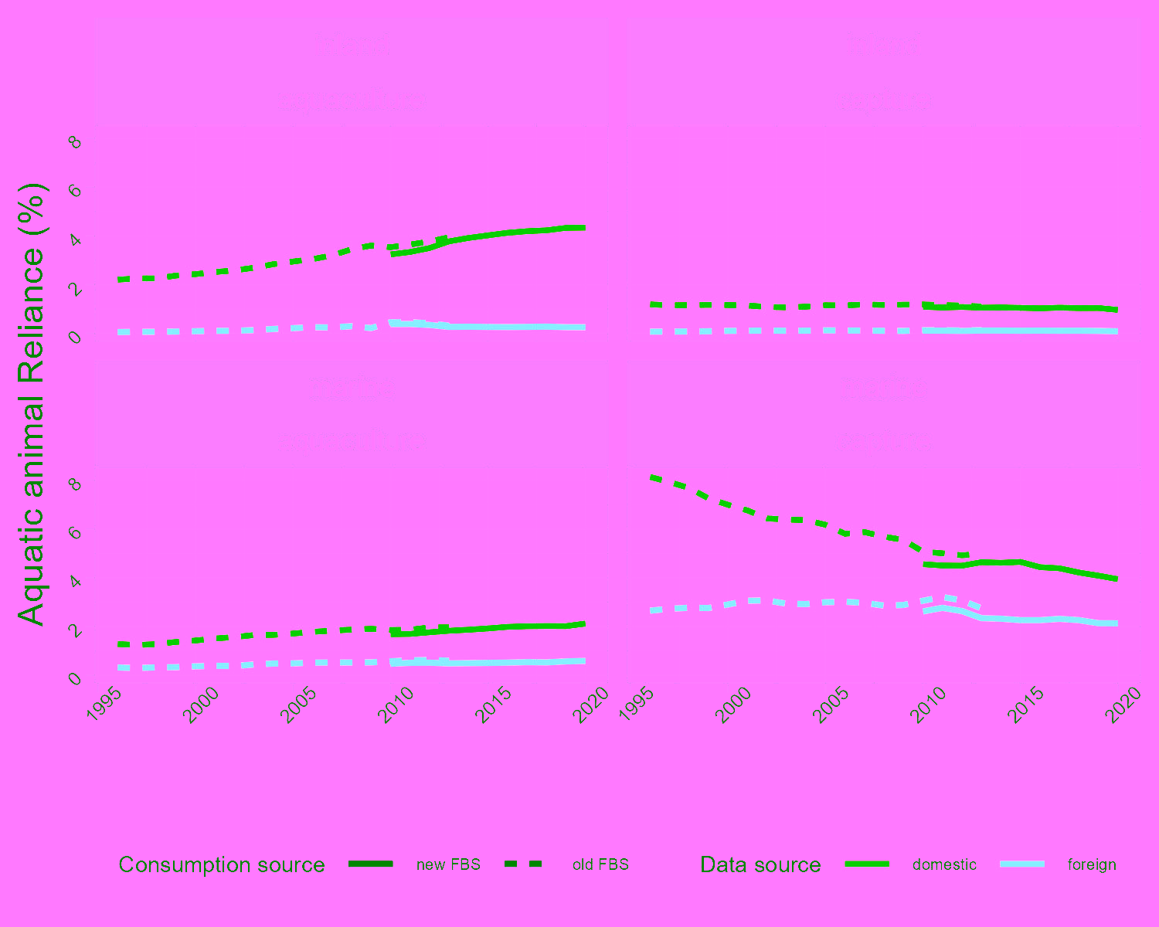

Figure 1. Trends in disaggregated aquatic animal protein reliance differs from the overall protein reliance which has hovered around 15% for the last 20 years (FAO 2023).

***Chapter 2 Context*** - *produce annual climate risk indices for Bayesian analysis*

Because marine capture is an important contributor to countries’ seafood reliance as well as being highly traded (Pending Quiroz Chapter 1; Gephart et al. 2024). We also know what marine capture seafood countries are consuming, down to the species (Gephart et al. 2024). While we know (0) what aquatic foods we consume (Gephart et al. 2024) and (1) how reliant we are on marine capture foods (pending Quiroz Chapter 1), we don't know (2) what the climate risk in countries’ marine capture food consumption are (i.e., my second thesis chapter). For this chapter I am answering the following research question: what is the relative climate risk in countries’ marine capture food supply?

Because seafood is important for countries’ aquatic food consumption, we need to understand what its current climate risks are if we want to continue sustainable marine capture foods. Specifically, we need to identify the climate risk in marine capture foods by sourcing (e.g., foreign / domestic production) as these reliances differ (Quiroz Chapter 1; Gephart et al. 2024). Because seafood is highly traded, impacts on a country’s stock doesn’t necessarily translate to impacts on their supply given their sourcing could be diversified through trade. Calculating risk by sourcing will allow us to figure out whether countries’ marine capture foods climate risk mainly comes from their imports, domestic production, or a combination of the two. This information can give governments a metric for evaluating their marine capture food prospects, enhancing decision making surrounding marine capture food sourcing, which could bolster economies and aquatic food security.

SeaAroundUs has data containing the 2030 predicted change in consumption portfolio under different scenarios of climate stress. Combining this with our reliance data and social-governmental infrastructures, we can describe (1) countries' reliances on marine capture (Quiroz Chapter 1); (2) their predicted change in seafood consumption under future climate stresses; and (3) their governmental infrastructure to adapt to changes in seafood volume. A way to measure a system’s risk to an environmental event is through the risk calculation developed by the International Panel on Climate Change: Risk = Exposure + Sensitivity - Adaptive Capacity. Future change in consumption will represent exposure, countries’ reliance on marine capture will represent sensitivity to the exposure (i.e., less marine capture reliance = less marine capture insecurity), and governments’ social-economic conditions will represent adaptive capacity. Each component in adaptive capacity will be treated equally for estimating country structure for analyzing Risk assessment will be computed for the most recent year of seafood consumption data, presenting current prospects on where our seafood consumption is safewise. This will produce risk indexes for each country, for each year of ARTIS data (given sufficient coverage of annual adaptive capacity variables).

## Methods

Identifying trends in countries’ climate risk on their marine capture aquatic food consumption could be done using frequentist analysis, but Bayesian applications will show us the uncertainty in our estimates instead of predicting a single value to fit our data. To model a regression for each country, I am proposing the following linear model to fit my risk data:



Where β0 is the y-intercept, β1 represents the change in seafood risk over time for each country, and epsilon is a normally distributed error. I am specifically interested in the β1,c component as this models the rate of change between countries’ risk over time, where a positive slope would denote an increase in countries risk and a negative slope would denote a decrease in countries’ risk. Through this I propose a hierarchical Bayesian model to derive the parameter estimates of the linear model (Figure 2).

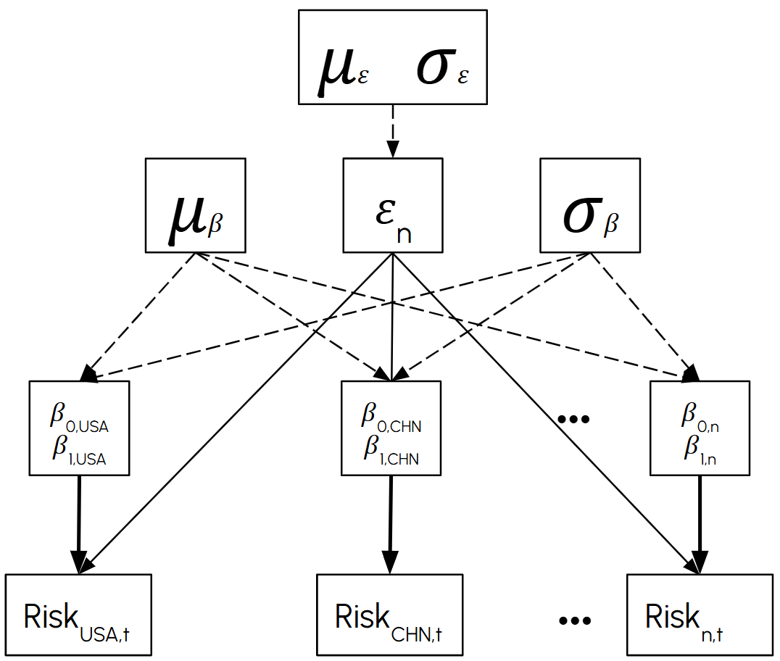

Figure 2: Proposed Bayesian model for this project. Dotted lines create parameters and solid lines estimate predictions on seafood risk (to be compared against observed data).

I am assuming that each β0 and β1 for each country comes from a hyperdistribution normally sampled from sigma and mu, which would make mu and sigma the random effects. I am assuming that the residual error will be the same across all models, making epsilon a fixed effect. Here is a table of my parameters that I will need to estimate along with their priors.

| **Parameter** | **Distribution** |
| --- | --- |
| με | TBD (uniform?) |
| σε | TBD (uniform?) |
| ε | N(με, σε ) |
| μβ | TBD (uniform?) |
| σβ | TBD (uniform?) |
| βc | N(μβ,σβ) |

Table 1.

I am only interested in producing posteriors for beta, which will tell us the rate of change for which an individual country’s seafood risk changes over time. While betas will be sampled from a normal distribution given hyperparameters sigma and mu, I am assuming that the residual error, epsilon to be controlled by an additional mu and sigma, will be separate

## Expected Results

I hypothesize that countries with an increasing risk (i.e., a majority of their posterior distribution for their slope being above 0), could be attributed to an increased marine capture reliance or worsened social governmental capacity to adapt to the climate stress on their aquatic food supply. I would expect the slopes for more socially-economically, marine capture reliant countries to also have an accelerated marine capture risk relative to more stable regions with more diversified consumption (more equal marine capture reliance compared to the other sourcing groups).

## References

FAO. “Food Balance Sheets 2010–2022. Global, Regional and Country Trends.” In *Statistics*. 2023.<https://www.fao.org/statistics/highlights-archive/highlights-detail/food-balance-sheets-2010-2022-global-regional-and-country-trends/en>.

FAO. “The State of World Fisheries and Aquaculture 2022.” 2022.<https://doi.org/10.4060/cc0461en>.

Gephart, Jessica A., Rahul Agrawal Bejarano, Kelvin Gorospe, et al. “Globalization of Wild Capture and Farmed Aquatic Foods.” *Nature Communications* 15, no. 1 (2024): 8026.<https://doi.org/10.1038/s41467-024-51965-8>.